Chemistry Study Guide 1
1 Convert the following. Use proper significant figures.
a) 35ft to m b) 72psi to atm c) 120°F to °C

d) 5.0gal to L e) 80.°C to K

2 Write in scientific notation with proper units. Use proper significant figures.
a) 745nm b) 1.6fs c) 55MPa

3 Write using a prefix and the proper unit. Use proper significant figures.
a) 3 370 000 000Pa b) 0.000 045L c) 0.000 000 28m

4 In lab, what instrument do you use to measure:
a) mass b) small volumes c) temperature

5 Liquid nitrogen is a commonly used cryogenic, and is really fun to play with!
i.) Nitrogen boils into the less fun gas nitrogen we’re used to at -320 °F. What is this temperature in degrees Celsius? Convert then to Kelvin.
ii.) Nitrogen freezes into a solid at 63 K. What is this in Celsius?

6 A server operates at 24kW of power. During a power outage, a back-up generator must power it to save information. What is the minimum horsepower rating for this generator?

7 Given common prefixes for scientific notation, write the following fictional unit quantities in prefix form. Ex: 6 x 10⁻⁹ m = 6 nanometers.
i ii

8 The Deepwater Horizon oil spill released an estimated 4.9 million barrels of crude oil into the
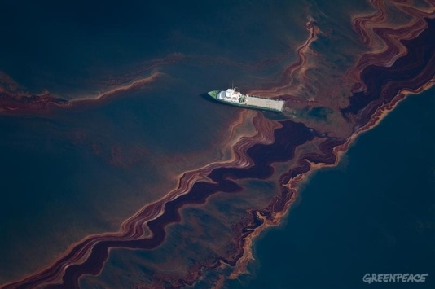
Gulf of Mexico. The explosion that caused the spill occurred on April 20, 2010. The spill was not contained until July 15, 2010.
a) Considering that a barrel of oil is 42gallons, calculate the total spill volume in cubic meters.

b) Calculate the average loss of oil (in barrels) per day.

c) Crude oil is currently trading at $88.81 per barrel. Assuming the cost of oil has not increased significantly, calculate the value of the oil lost by BP.

d) Calculate the loss in oil revenue per day, due to the spill.

9 A vet asks a dog owner to weigh the dog every day for five days. He obtains the following results
(in lb): 19, 22, 21, 25, 23. In the vet’s office (with a well-calibrated scale), the dog is 22lb.
a) Are these results precise, accurate, both, or neither? Explain.

b) Are any of the measurements outliers? What might explain the variation of these measurements, and how could the dog owner minimize the error in data?

10 A graduated cylinder (maximum measurement of 25mL) is initially filled with 8.7mL of water. After adding 46.592g of several grayish (some shiny) metal pellets, the volume increases to 15.1mL.
a) Draw what these volume measurements look like in lab (two pictures).
b) Identify the metal. Explain how you come to this conclusion.
If the measurement falls between two metals, guess which is closest.
Metal | Density (g/mL)
Al  Cu  Fe  Au  Pb  Sn  Zn | 2.70  8.96  7.87  19.3  11.3  7.26  7.14

