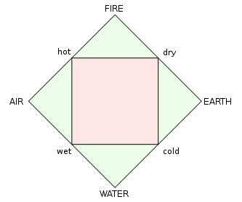Atomic Theory

**Ancient Atomic and Element Theory**

- first theory of elements was by Greek philosopher ___________________ (440BC)

- his student ________________ carried out his work (384-322BC)

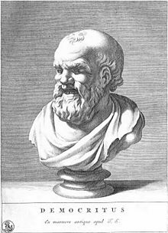 - emphasized the five __________________that all matter is made of:

Democritus

- the less popular theory was by the philosopher ____________________ (470-370BC)

- his idea was that all matter was divisible up to a certain point

- you eventually get down to a particle that is __________________

- the Greek word translates to “not cuttable” or _________________

- of the two theories, the _________________ idea was followed for several centuries

**Classical Atomic Theory**

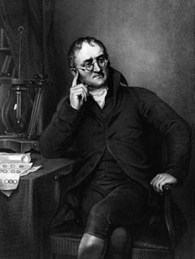

John ____________ (1803-1810)

- first atomic theory, with the criteria:

1. Elements are composed small, indivisible particles called ______________

2. Atoms of the same element have the same __________ and ___________ ; atoms of different elements have different __________ and ___________

3. Atoms cannot be nor .

4. Compounds are formed by the combination of two or more different _____________ in simple .

5. In chemical reactions, atoms are combined, separated, or generally .

Dalton’s Theory of Compounds

*Law of Definite Proportions*

*Law of Multiple Proportions*

Ex Give two (or more) compounds involving the following elements. Do not use any other elements.

1. Hydrogen and Oxygen b) Nitrogen and Oxygen c) Carbon and Oxygen

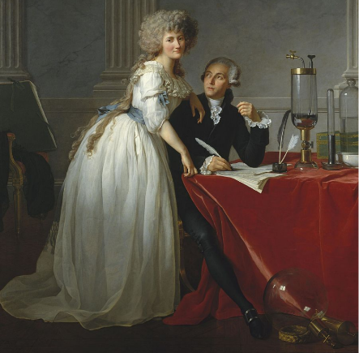Antoine Lavoisier (late 1700s)

* Early experiments in chemistry
  + Oxygen theory of   
    (opposes phlogiston theory)
* Age 28 marries Marie-Anne Paulze (13 years old)
  + Favor to his boss
  + Expert on language, translates other chemist works
  + Lab tech, writes all reports, technical drawings
* Executed during
  + Wife rescued his works
* Known for very accurate drawings and measurements

Joseph Priestly (1700s)

* Highly religious Christian scientist, known as a founder of
* Experimented and observed several different gases or “ “, notably:
* Isolated and discovered pure, elemental
  + Found its connection with , and its function in blood
* 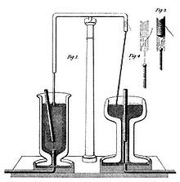Unfortunately connected many ideas to theory

Michael ______________ (early to mid 1800s)

- discovers ______________ ___________, which has two types: ______________ & ______________

- similar charges _____________, opposite charges ____________

- charges can be transferred; such charged particles are called _______

- this means ______________

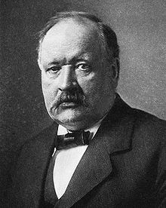  
Svante _______________ (late 1800s)

- found that when exposed to a charge, ions moved towards ________________:

- thus, due to their *attraction*, the ions are labeled:

J.J. ______________________ (1897)

- used a Crook’s tube, which is a simple ________________ __________ and ran an electric current through it

- a visible ray shot from the negative side to the positive side

- since it was a _____________ tube, there would be nothing to transfer this, so it must be a particle

- since it came from electricity, he named it the ______________________

- a later experiment used a magnet to bend the ray, proving that it has a _______________________ charge

Robert ____________________ (1908)

- _________ __________ experiment proved that there is a ___________________ ___________

- all charges come in multiples of a certain number:

Dalton’s atomic theory no longer works since atoms are divisible into __________________ particles

- Thomson proposes the ____________ _______________ model

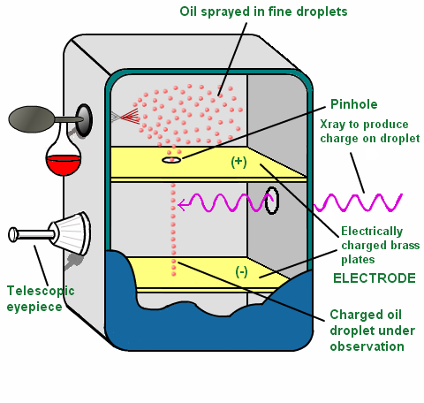

Ernest ______________ (1907)

- used the _____-particle discovered by Henri _____________ to prove Thomson’s model

- this was his famous ____________ ___________ _________________

- actually performed by Hans Geiger and Ernest Marsden, based on Rutherford’s theories

James ______________ (1932)

- also used alpha particles shot at a beryllium foil

- a piece of ______________ wax caught the radiation, and hydrogen atoms were displaced

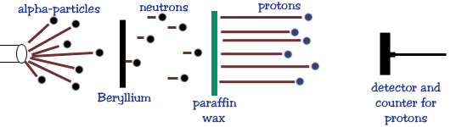- his particle did not have a charge and was as heavy as hydrogen

- this was the _______________

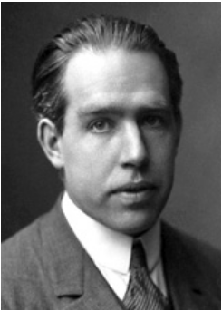

The Bohr Model Atom

- chemist G.N. _________________remarked that the atom was like a seed,

composed of a ________________ and _______________

- the name ___________________ was adopted, Greek for ________

- Neils Bohr proposed that the atom worked like planets

- nucleus was heavy like the Sun

- electrons surrounded the nucleus, in circular _________________

- this model proved to be wrong, but is still used for simplicity

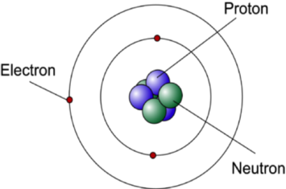Atomic Structure

* Atoms are composed of three particles

|  |  |  |
| --- | --- | --- |
|  | Charge | Determines |
| Proton |  |  |
| Neutron |  |  |
| Electron |  |  |

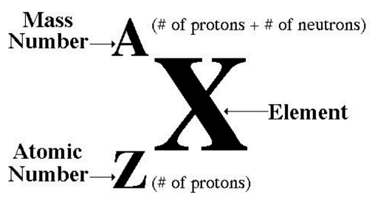Isotopes

* Meaning “same place”
* Refers to location on
* Elements have same protons, but different
* Usually expressed as a :

Ex Carbon-14 is used in dating artifacts and very old samples. How many neutrons does carbon 14 have?

Ions

* Caused by an imbalance of electrons
  + More electrons means a charge

|  |  |  |  |  |  |
| --- | --- | --- | --- | --- | --- |
| **Symbol** | **Atomic Number** | **Mass**  **Number** | **Protons** | **Neutrons** | **Electrons** |
| *O* | 8 | 18 | 8 | 10 |  |
|  | 1 | 3 |  |  | 1 |
| *Mg2+* |  | 26 |  |  |  |
|  |  | 66 | 30 |  | 28 |
|  |  |  | 19 | 20 | 20 |
| *S2-* |  |  |  | 18 |  |
| *52Cr3+* |  |  |  |  |  |

|  |  |  |  |  |  |
| --- | --- | --- | --- | --- | --- |
| **Symbol** | **Atomic Number** | **Mass**  **Number** | **Protons** | **Neutrons** | **Electrons** |
| *O* | 8 | 18 | 8 | 10 |  |
|  | 1 | 3 |  |  | 1 |
| *Mg2+* |  | 26 |  |  |  |
|  |  | 66 | 30 |  | 28 |
|  |  |  | 19 | 20 | 20 |
| *S2-* |  |  |  | 18 |  |
| *52Cr3+* |  |  |  |  |  |