Balancing Equations Practice
Chemistry ^{Name}

1 Hydrogen gas combines with nitrogen gas to form ammonia, which has the formula NH₃.
a) Write an equation for this chemical reaction, then balance.
b) Draw a picture to show how this reaction occurs at the atomic level.
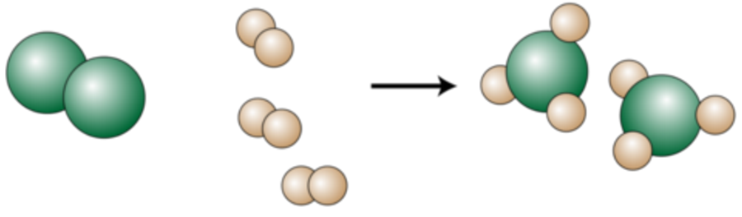

2 Balance the following equation. Then indicate the number of atoms of each element that exist on each side of the equation. The reactant and product numbers should equal each other.

_1_ (NH₄)₂SO₄ + _2_NaOH → _2_NH₃ + _2_H₂O + _1_Na₂SO₄

 | reactant | product
H | 10 | 10
O | 6 | 6
N | 2 | 2
S | 1 | 1
Na | 2 | 2

3 Balance each of the following equations.
a. _6_Mg + _1_P₄ → _2_Mg₃P₂
magnesium phosphorus magnesium phosphide
b. _1_Ca + _2_H₂O → _1_Ca(OH)₂ + _1_H₂
calcium water calcium hydroxide hydrogen
c. _1_CuCO₃ + _1_H₂SO₄ → _1_CuSO₄ + _1_H₂O + _1_CO₂
copper(II) carbonate sulfuric acid copper(II) sulfate water carbon dioxide
d. _1_CaCl₂ + _1_Na₂CO₃ → _1_CaCO₃ + _2_NaCl
calcium chloride sodium carbonate calcium carbonate sodium chloride
e. _1_C₁₂H₂₂O₁₁ + _12_O₂ → _12_CO₂ + _11_H₂O
sucrose oxygen carbon dioxide water

Score | Grade
4 | A | I can explain & teach others
3 | B | I can practice without help from the teacher
2 | C | I can practice with some assistance
1 | D | I can practice but with frequent assistance
0 | F | No attempt at problem stated

