Bonding & Lewis Structures

**Electrons in Atoms** *How many core and valence electrons are in…?*

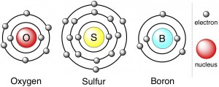Two types of electrons:

*Core*

*Valence*

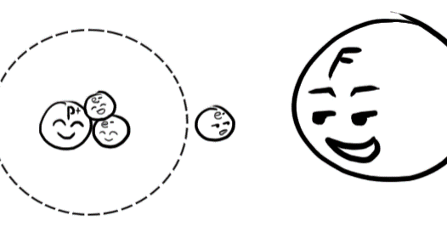**Ionic Compounds**

Electrons are physically moved from one place to the next

- metals lose electrons to have net charge

- nonmetals gain electrons to have net charge

When electron transfers, imbalance of p+ and e- causes orbital to:

|  |  |
| --- | --- |
| ***Shrink*** for ____________  - nucleus pulls harder w/ less electrons | ***Expand*** for __________  - nucleus protons have less influence |

Ex Draw the formation of lithium fluoride.

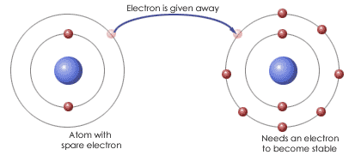

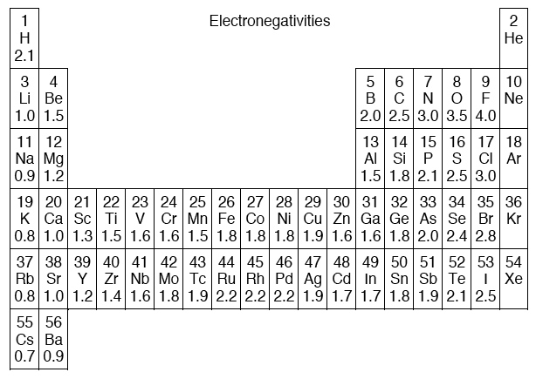

**Polarity: Dipoles and Electronegativity**

- in many cases, charge is unevenly distributed in a molecule

- result is a ____________ ____________

- that is, an electric force across the distance of the bond

- three possibilities

***Nonpolar covalent***

***Polar Covalent***

***Ionic***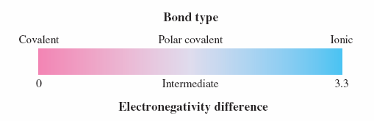

**Question**: How can we tell if it’s polar or nonpolar?

- use difference in ___________________________________

-

- large difference means more polar

- very large difference means it is ionic ()

Ex For each compound, calculate a nonpolar, polar, or ionic compound. If polar, tell which atom holds the electron more. If ionic, tell which atom gains and which atom loses an electron.

a) HF b) NaCl c) F2

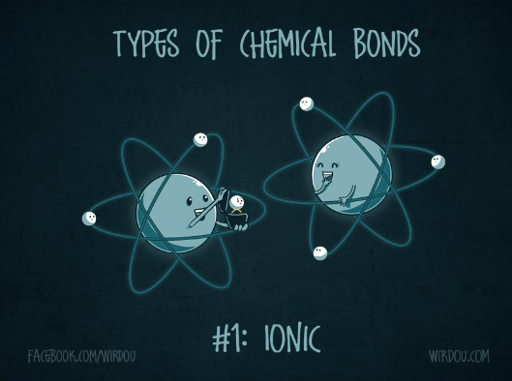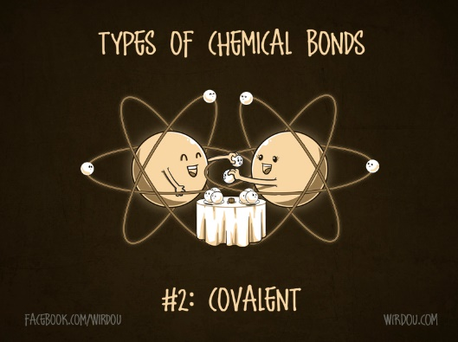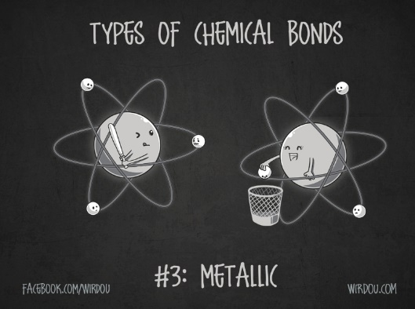

**Polarity in Whole Molecules**

- sometimes you have polar bonds, but *nonpolar* molecules

- this is because dipole moments point in specific directions

- if pointing in opposite directions w/ same magnitude, they cancel

- We use two types of notation:

**Dipole**  *arrow w/ plus sign at more positive end*

**Polarity**   *Greek letter  “delta” with sign*

Ex Draw each compound’s polarity & dipole.

a) HCl has an uneven sharing of electrons b) CO2 lines up as OCO, making it nonpolar

**Lewis Structures**

- these allow us to specifically count electrons *only* for atoms

- these are particularly useful in covalent bonding

- to do this, we use a “dash” line to indicate a bond

- we may also use these for ionic bonds

- *Note:* ***These are not space orientations!***  *Just bookkeeping of electrons!*

- Notation:

Electrons  dots

Element  symbol

- some other important facts

i. We use the ____________ __________ ; hence, **eight electrons max** go around an element

- as such, don’t count *d*-electrons for now

ii. Hydrogen and Helium require only two electrons to be stable

iii. Charges affect number of electrons

- Positive charge means to *___________________* electrons

- Negative charge means to ___________________ electrons

iv. Shared electrons count as TWO electrons for each atom

v. Try to fulfill octet for all atoms

- to do this, you may need to or bond with available electrons

Ex Draw the Lewis structure of each atom on the given example.

a) He b) Kr c) N d) Cl

Hydrogen and halogen molecules are easy to keep track of

- each of these requires only bond (thus they are always at ends)

Ex Draw the Lewis structure.

|  |  |  |
| --- | --- | --- |
| a) H2 | b) HCl | c) SCl2 |

In many cases, to obey the octet rule we have to or bond

- this makes sense of the **diatomic** molecules, and why they are so stable

Ex Draw the Lewis structure for each diatomic molecule.

|  |  |  |
| --- | --- | --- |
| a) Cl2 | b) O2 | c) N2 |

Ex Draw each Lewis structure.

|  |  |  |
| --- | --- | --- |
| a) N2F2 | b) SeO2 | c) CO |

**Rule:** Carbon usually forms four bonds. Carbon is the basis of _________________ chemistry.

Ex Draw the Lewis structure of each carbon compound.

|  |  |  |
| --- | --- | --- |
| a) CF4 | b) CH2Cl2 | c) C2H6 |
| d) C2H2 | e) CH3OH | f) CH2O |

**Lewis Structures of Ionic compounds**

- these must show an explicit exchange of electrons in the initial and final forms

- usually, one atom appears to have no electrons and the other has an octet

- in reality, every atom has an octet!

- in final form, show signs explicitly [*element symbol placed in brackets*]

Ex Show the transfer of electron in the following ionic Lewis structures.

|  |  |
| --- | --- |
| a) Li2O | b) MgS |

**Resonance Structures**

- these occur when there are multiple ways to draw structures

- the actual structure is something in between Lewis Structures we come up with

- indicate irregular geometries (but we won’t worry about that quite yet)

Ex Draw all resonance structures.

|  |  |
| --- | --- |
| a) SO2 (two resonance structures) | b) NO3- (three resonance structures) |

**Exceptions to the Octet Rule**

Some less common geometries arise when we break the Octet Rule

- some atoms are simply more stable when they are electron

Ex Exceptions to the octet rule.

|  |  |
| --- | --- |
| BeCl2 | BF3 |

**Molecular Geometries**

- we use the VSEPR:

- model is based on the idea that electron PAIRS repel each other

- thus, we must maximize the distance between electron pairs

Two types of electron pairs

i. bonded pairs

ii. lone pairs

- these are very important in defining shape for molecules of three or more atoms

- require *slightly* more space than bonded pairs

Ex Diatomic Molecules are always :

Ex Use the Lewis structure of each molecule to predict its molecular geometry.

|  |  |
| --- | --- |
| CH4 | NH3 |
| H2O | CO2 |

Polyatomic ions combine molecular and ionic properties

- notice that the charge increases or decreses number of electrons

- the PI is actually molecular w/ a net charge

- compound is ionic

Ex MgSO4

Much more complicated are cases of __________________

- that is, some atoms may effectively use BOTH *p-* and *d-orbitals* together

- this allows for some much more complex geometries

- to predict spatial arrangement, note that lone pairs need AT LEAST a 90° angle

- the most common atoms to have more than eight valence electrons are sulfur and phosphorus

Ex PCl5  SF6

SF4  XeF4