Chemical Equations 2

Chemistry Name

1 Balance each of the following equations. Classify each reaction as combination, decomposition, single- displacement, or double-displacement.

(a) ___ H2 + ___ O2→___ H2O (b) ___ C + ___ Fe2O3→___ Fe + ___ CO

(c) ___ H2SO4 + ___ NaOH→___ H2O + ___ Na2SO4 (d) ___ Al2(CO3)3 ___ Al2O3 + ___ CO2

(e) ___ NH4I + ___ Cl2→___ NH4Cl + ___ I2 (f) ___ H2O2→___ H2O + ___ O2

(g) ___ CrCl3 + ___ AgNO3→___ Cr(NO3)3 + ___ AgCl (h) ___ Ba(ClO3)2 ___ BaCl2 + ___ O2

(i) ___ Al + ___ C___ Al4C3 (j) ___ H2 + ___ Br2→___ HBr

2 Balance the following equations:

(a) ___ Cu(NO3)2→CuO + ___ NO2 + ___ O2 (b) ___ FeS + ___ O2→___ Fe2O3 + ___ SO2

(c) ___ HCN + ___ O2→___ N2 + ___ CO2 + ___ H2O(d) ___ Al + ___ H2SO4→___ Al2(SO4)3 + ___ H2

(e) ___ NO2 + ___ H2O→___ HNO3 + ___ NO (f) ___Mg3N2 + ___H2O→___Mg(OH)2 + ___NH3

(g) ___ B5H9 + ___ O2→___ B2O3 + ___ H2O(h) ___ MnO2 + ___ CO→___ Mn2O3 + ___ CO2

(i) ___ C3H5(NO3)3→___ CO2 + ___ H2O + ___ N2 + ___ O2

3 Change these word equations into formula equations and balance them. Be sure to use the proper symbols to indicate the state of each substance, as given.

(a) Magnesium metal is placed into hydrobromic acid solution, forming hydrogen gas and aqueous magnesium bromide.

(b) When heated, solid calcium chlorate decomposes into calcium chloride solid, releasing oxygen gas.

(c) Lithium metal reacts with oxygen gas to form solid lithium oxide.

(d) Solutions of barium bromate and sodium phosphate combine to form solid barium phosphate and aqueous sodium bromate.

(e) Solutions of acetic acid and sodium carbonate are mixed together, forming a solution of sodium acetate, along with carbon dioxide gas and liquid water.

(f) Solutions of silver nitrate and aluminum iodide are mixed together, forming solid silver iodide and aqueous aluminum nitrate.

4 Balance the following reactions, and then add to their pictorial representations.

a) ___ CH4 + ___ O2 → ___ CO2 + ___ H2O

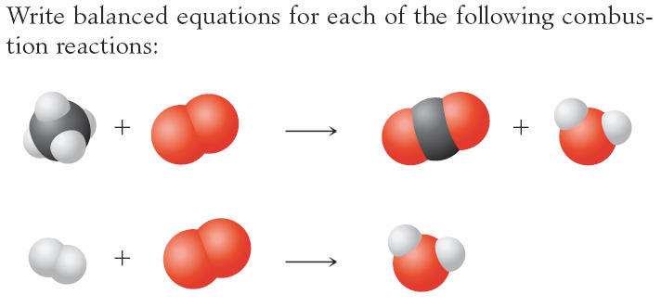

b) ___ H2 + ___ O2  → ___ H2O



5 Write balanced equations for the complete combustion of ethanol, C2H5OH. Then draw a picture of the reaction.