Chemical Equilibrium

Reversible Reactions

* Some reactions, such as acid/base reactions, are
  + They move in only one direction
* Many reactions occur such that products can react to the produce the original reactant

Ex Decomposition of dinitrogen tetroxide occurs when heated. What happens if you cool the product?

Write a balanced equilibrium reaction.

Kinetics

* Reaction rates can be modeled using chemical
* The of the reaction is related to the concentration of a reactant
* Given a general reaction: *A → B ,* we can deduce that:
* The order of the reaction could be measured. Examples of reaction orders for this general reaction might be:

|  |  |  |  |
| --- | --- | --- | --- |
| **Order** |  |  |  |
| **Rate Law** |  |  |  |
| **Concentration**  **Graph over Time** |  |  |  |

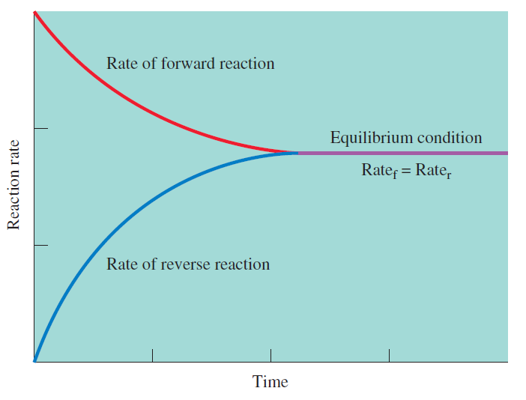

**Equilibrium is the condition such that for a reaction, the reaction in the direction is equal to the of the reaction.**

Le Chatelier’s Principle

**If a is applied to a system in , the system will respond in such a way as**

**to relieve that stress and restore under a new set of conditions.**

* This means that equilibrium can between “reactant” and “product” side if any changes are made
* Typical changes are:

Effect of Concentration

* Adding more of a chemical species (holding all others constant) will shift equilibrium to the opposite side of the equation

Ex Acetic acid is a weak acid. What is the effect of adding a drop of 16M HCl to a beaker of acetic acid? Does the concentration of acetate increase or decrease?

Effect of Temperature

* Equilibrium reactions may require heat to start or release heat
* Recall these definitions
  + Exothermic
  + Endothermic
* Increasing temperature pushes equilibrium away from the side where is present  
  + Cooling would do the opposite, and favor the reaction that heat

Ex What effect would an increase in temperature have on the position of the equilibrium in these reactions?

|  |  |
| --- | --- |
|  |  |

Effect of Volume or Pressure (reactions involving gases)

* Decreasing volume for a gas increases the pressure
* A decrease in volume is equivalent to increasing
* Therefore, a decrease in volume favors the side that number of total atoms/molecules
  + This applies to reactions that involve gas particles

Ex Will the equilibrium shift to the left or right when the reaction vessel is compressed?

|  |  |
| --- | --- |
|  |  |
|  |  |

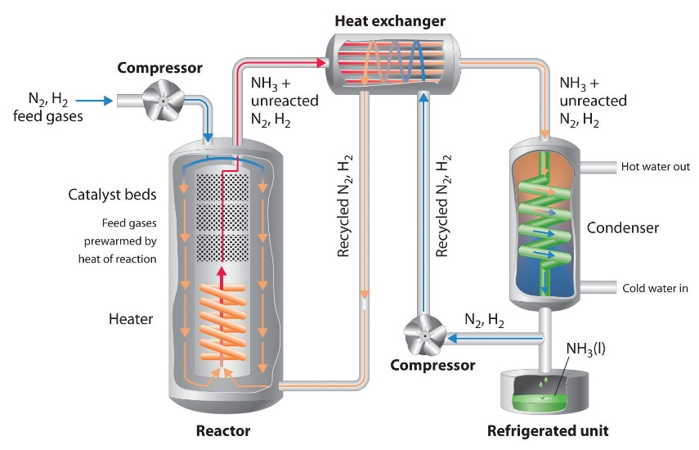Ex The Haber Process

Nitrogen and hydrogen combine to produce ammonia in an equilibrium. Ammonia is an important chemical in production of fertilizers, but is difficult to produce without decomposing into its reactant parts. Write an equilibrium expression for the production of ammonia. Then, speculate how its equilibrium can be shifted?

