Chemical Reactions

**Chemical reactions**

- cause chemical changes

- how do we know when a reaction has taken place?

OBSERVATIONS

MEASUREMENTS

What’s really going on?

- atoms *physically* rearrange themselves

- come together, break apart, swap partners

- atoms must be in close proximity for reaction to take place

- we can increase this likelihood by adding heat

**Word equations**

- verbal description of reaction (just as valid as any description)

Pros: used in lab, fastest way to communicate

Cons: no indication of number of atoms, uses technical jargon (not everyone will understand)

Ex H2SO4 combines on an Al sheet to form Al2(SO4)3 and H2 gas:

Ex All hydrocarbons can be “cleanly” burned with oxygen to form carbon dioxide and water:

*Note: we never know how many ________________ we need, or how many _________________ form*

**Chemical Equation**

- show each atom and proportions of compounds as an equation

Ex Decomposition of glucose: 

\**notice the convention of whole number ________________*

- in words: We need to start a reaction

We make using the reaction

- chemical equations also indicate:

|  |  |  |
| --- | --- | --- |
| **• states of matter:**  solid  liquid  gas  aqueous | **• energy used or conditions**  (indicated on top/bottom of arrow)  heat light  pressure temperature  catalyst | **• direction of reaction**  forward  backwards  reversible |

Ex Fill in any possible additional information.

a)  b) 

**Balancing Equations**

*Law of Conservation of Mass*

- so we cannot “lose” atoms in a chemical reaction

- we must always account for every atom and where it goes

- remember, a chemical equation is still an EQUATION!

- atoms must appear in both reactant and product

- no mass can be *lost* from one side to the next

- many times, we only know the reactants and products, but not proportions

- our task is to *balance* the equation, one element at a time

Keep in mind that the following always start as _______________ molecules:

Ex Water forms from hydrogen and oxygen gas. Write a balanced reaction for this process. Then draw a picture of how this reaction occurs.

* *so we see that we cannot produce only one water, and we had to start with twice as much hydrogen*

- what if we had equal parts hydrogen and oxygen?

**A few helpful hints for balancing equations**

i) **Trial and Error** is usually the best method 

ii) Start with **complicated** **compounds**

- these tend to *unbalance* everything else when we change them

iii) Keep track of things that must be **even/odd**

- in some cases, even numbers are required (like the case of diatomic molecules

iv) **Neglect** anything that is very easily changed

- like elemental substances

v) Leave **hydrogen** and **oxygen** to balance last, since many reactions involve H2, O2, and H2O

|  |  |  |
| --- | --- | --- |
|  | Reactant | Product |
| C |  |  |
| H |  |  |
| O |  |  |

… *and finally, RELAX, go through it!*

Ex Balance the equation. Use a pencil and keep track of atoms.

|  |  |  |
| --- | --- | --- |
|  | Reactant | Product |
| N |  |  |
| H |  |  |
| O |  |  |
| Cr |  |  |

a) 

|  |  |  |
| --- | --- | --- |
|  | Reactant | Product |
|  |  |  |
|  |  |  |
|  |  |  |
|  |  |  |

b)

c)

**Types of reactions**

- reactions are grouped by how atoms are rearranged (with intuitively associated names)

- if we know how they are rearranged, we can ______________ ______________

**Getting together and breaking up**

i)

- two (or more) reactants come together to make a more complex product

Ex 

Ex  

ii)

- larger compound breaks down to smaller compounds

- opposite of combination reaction

Ex 

Ex 

**Displacement Reactions**

i)

- general form:

Ex 

Ex 

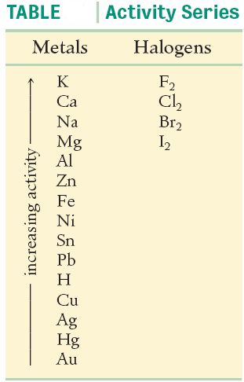

Ex Some metals are more reactive than others. The same is true of halogens.

These are shown as part of the .

More active elements can force displacement reactions.





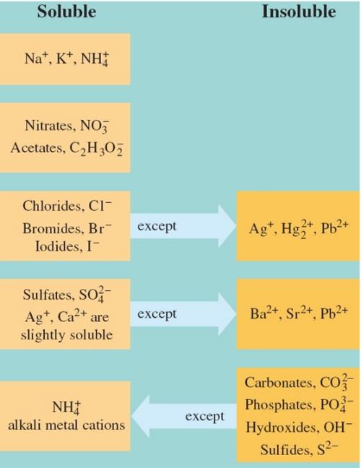ii)

- general form:

Ex





Ex





Ex





**Oxidation-reduction Reactions**

- reaction in which a ____________ atom becomes an ______

- used for ___________________________

- very difficult to balance, since you must balance both and

Ex Indicate the charge on each chemical species for the following oxidation-reduction equation:

Zn(*s*) + H2SO4(*aq*) → ZnSO4(*aq*) + H2(*g*)

**Evidence of Reactions**

*Examples* 