Chemical Equations in Words
Chemistry ^{Name}
Write a chemical equation and balance for each of the following reactions.
1 Aqueous solutions of lead(II) nitrate and potassium bromide are mixed together.
The solution turns cloudy white during the reaction.

2 Solid mercury(II) oxide decomposes into liquid mercury and oxygen gas upon the absorption of heat.

3 Calcium metal reacts with water to produce calcium hydroxide and hydrogen gas.

4 Sodium carbonate decomposes when heated.

5 ______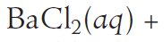______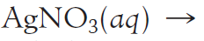

6 ______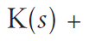______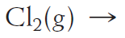

7 ______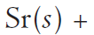______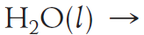

8 ______