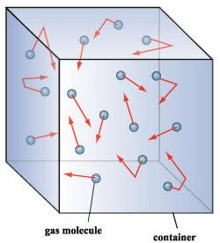Ideal Gases

The Kinetic Theory of Gases

An ideal gas is said to have the following characteristics:

1. Very small particles with relatively large

* thus few with other gas particles & walls

1. Perfectly collisions with particles and wall

* No forces at all

1. energy is proportional to

* As particles heat up, they move faster

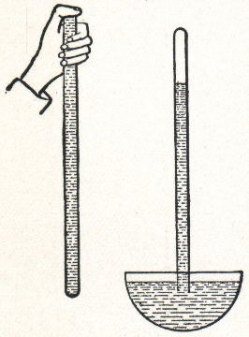Gas Measurements

- gases are nearly impossible to quantify with mass or volume

- this is because gases ______________ and are not ___________________ in space

- 1640s, Italian physicist/mathematician Evangelista

invents a simple using an inverted tube of

- 1650s, the German scientist ___________ ______ ______________ invented the vacuum pump

- famous demonstration had horses pull two empty hemispheres

- repeated for Friederich Wilhelm I

- Irish scientist _____________ _____________ invented a ________________ using _____________

- under “normal” conditions, the height was ____________

- weather would change the reading

- _______________ is the standard measurement for gases

- in chemistry, the most common unit is the ___________________, or _________

- practical applications use the pound per square inch, or ___________

- in physics, the SI unit is the ______________, but most measurements are in __________

- the short form that is nearly an atmosphere is the _________:

- Standard Temperature and Pressure, or __________, is defined scientifically as:

Gas relationships

- the following scientists are credited for the gas laws:

***Scientist Law Relationship***

Ex Given the following information, determine the appropriate gas law and solve for the missing variable.

a) A tire on the road is inflated to 45psi at 22°C. While driving, friction heats it to 120°C. Since the tire cannot expand, calculate the final pressure.

b) A piston is compressed at standard atmospheric pressure and a volume of 40.mL down to a volume of 5.0mL. Calculate the pressure at this volume.

c) An inflatable bladder holds 4.8mol of a gas at a volume of 2.2L. Calculate the number of moles required for it to reach 6.0L.

d) A pressure cooker has 2.5L of space to hold a gas. It is initially at 1.1atm when held at room temperature of 25°. Water is allowed to boil, raising the gas temperature. Calculate the new pressure in the cooker.

The Combined Gas Law

- we can combine all of our gas laws into one equation

- we may use this for any of these types of problems

- variables that are held are unnecessary on either side of the equation

- quantities that change are necessary and should be kept

Ex The volume of a weather balloon is 8.0m3 at 310K on the ground. As it rises, the temperature drops to 220K, the volume of the balloon increases to 12m2. a) Calculate the pressure of the balloon at this height. b) Using the physical relationship *P = Patm + dgh*, calculate the height; here, *g* = 9.8m/s2, the acceleration due to gravity.

Ex A sealed tank of volume 0.10m3 contains air at 27°C° under 18kPa of pressure. The valve can withstand 50kPa of pressure. a) What is the maximum temperature of this gas without releasing any? b) Suppose you needed to raise the temperature to that in part (a) but maintain a pressure of 18kPa; how much of the gas must you release?

Ex A clown brings a helium tank to a party. When full, each balloon is a sphere of radius 35cm. The tank is a cylinder at a pressure of 16MPa, and it has a height of 1.3m and radius of 0.22cm. Calculate the number of balloons he can fill.

The Ideal Gas Law

- we can combine all of the gas laws, leaving one side constant to arrive at the Ideal Gas Law:

- the constant *R* comes from the fact that this is proven using _______________ ___________

- it is the constant multiplied by number

Ex Use the ideal gas law to solve each problem. Show all unit conversions.

a) A hot air balloon runs at 380°C. It holds 50.kg of helium, and flies where the pressure is only 0.86atm. Calculate the volume of the balloon.

b) A 145L water tank at 29°C and 736torr is “empty”. How many moles of air are in it?

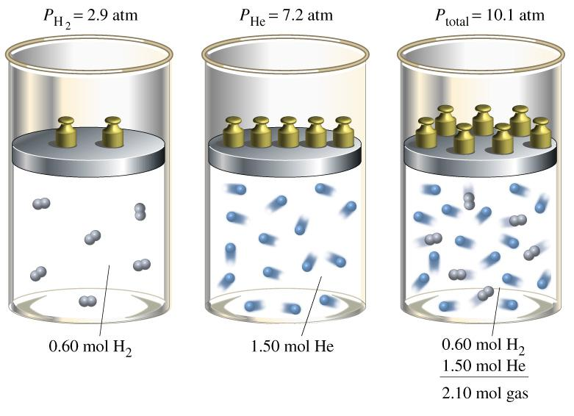

Dalton’s Law of Partial Pressures

- when gases mix, their pressures add to give a pressure

- in this sense, the contribution from each gas is only a

pressure

Ex On a hot and humid day, the air is composed of 13% water vapor, 16% oxygen, and the rest is nitrogen at sea level (760 torr). Calculate the partial pressures of each gas.

Ex Dry air is composed of 78%N, 21%O, and 1% Ar. A 20.L sample of air is taken on a hot (37°C) day, when the pressure is 770torr. Calculate the total number of moles in the sample, and the number of moles of each gas taken.

Density of Gases

- we can use some simple stoichiometry in the Ideal Gas law to solve for the density of any gas based on molecular weight

Ex The density of air is 1.29g/L at STP. Calculate the theoretical molar mass of air.