Naming Ions (Advanced)
Chemistry ^{Name}
1 Write formulas for these compounds:
(a) tin(IV) bromide (d) mercury(II) nitrate
(b) copper(I) sulfate (e) titanium(IV) sulfide
(c) iron(III) carbonate (f) iron(II) acetate
2 Write formulas for these compounds:
(a) silver sulfite (b) cobalt(II) bromide
(c) tin(II) hydroxide (d) aluminum sulfate
(e) manganese(II) fluoride (f) ammonium carbonate
(g) chromium(III) oxide (h) copper(II) chloride
(i) potassium permanganate (j) barium nitrate
(k) sodium hydroxide (l) iron(II) sulfate
(m) potassium chromate (n) bismuth(III) chromate
3 Write the name of each compound:
(a) Cd(NO₃)₂ (f) Cr(ClO₃)₃
(b) NiS (g) Ag₃PO₄
(c) CuCO₃ (h) Al(C₂H₃O₂)₃
(d) HgCl₂ (i) BaCrO₄
(e) ZnSO₄ (j) CoF₂
4 Write formulas for these compounds:
(a) sodium chromate (b) magnesium hydride
(c) nickel(II) acetate (d) calcium chlorate
(e) lead(II) nitrate (f) potassium phosphate
(g) manganese(II) hydroxide (h) cobalt(II) carbonate
(i) sodium chlorate (j) arsenic(V) carbonate
(k) chromium(III) sulfate (l) antimony(III) sulfate
(m) sodium acetate (n) potassium cyanate
5 Write the name of each compound:
(a) NaClO₃ (f) FeBr₃
(b) Sn(NO₃)₂ (g) (NH₄)₃PO₄
(c) As₂(SO₄)₃ (h) Fe(CN)₂
(d) BiSO₄ (i) CaSO₄
(e) K₂CO₃ (j) KMnO₄
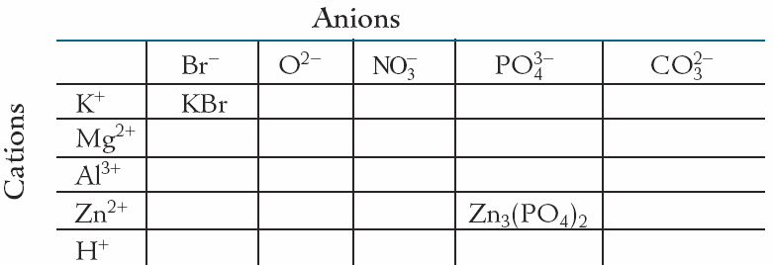
6 Fill in the table with balanced compounds made up from the given ions.

