Organic Chemistry

Organic Chemistry history
- Organic chemistry is the study of carbon and carbon containing molecules
- It spans across many applied disciplines, but in particular:
  - Polymer chemistry
  - Petroleum engineering
  - Biochemistry
Organic chemistry wasn’t always well known
- Until the early 19th century, the ___________________ theory simply assumed there were living things (organic chemicals) and non-living things (inorganic molecules)
- In 1828, Friedrich Wöhler accidentally synthesized urea
- “I must tell you that I can prepare urea without requiring a kidney or an animal, either man or dog.”
- From then on, organic simply meant that the compounds contained carbon

* Note: Not everything containing carbon is considered organic
- Ex: CO₂
- similarly, we include VERY few things that don’t contain carbon at all

What’s so great about carbon?
- carbon has four valence electrons
- it NEEDS four more for a stable octet
- it gets these by sharing four electrons in bonds
- no really, it NEEDS FOUR BONDS ALWAYS!

- note that carbon uses _________________ orbitals
- this means its orbitals point in 3-D directions to minimize e⁻ pair angles

Carbon compounds come in a few main groups
- these are supplemented by _______________ that may add additional properties to molecules
- ________________ are molecules made entirely of hydrogen and carbon
- if saturated, there are ONLY single bonds

- These include _______________
- if unsaturated, there are one or more DOUBLE or TRIPLE bonds
- These include _______________, ________________, and ______________________
* yes, this same analysis applies to biomolecules
- you may have heard of saturated or unsaturated fats
- saturated means only single bonds
- unsaturated means they contain double or triple bonds, called “___________”
Isomerism
- this is the phenomena of two compounds having the same molecular formula, but different spatial arrangements
- this is especially important in biochemistry, since much of it is dependent on chemical shape

Ex: Find two isomers with the formula .

Alkanes, Alkenes, and Alkynes
- Alkanes
- straight- or branched-chain hydrocarbons with only SINGLE BONDS between carbons
- these have the formula
- Alkenes
- unsaturated hydrocarbons containing at least one DOUBLE bond between carbons
- this results in two fewer hydrogens than alkanes
- Alkynes
- unsaturated hydrocarbons containing at least one TRIPLE bond between carbons
- this results in four fewer hydrogens than alkanes
- we use the simple numbering system:
1 | 2 | 3 | 4 | 5 | 6 | 7 | 8 | 9 | 10
meth- | eth- | prop- | but- | pent- | hex- | hept- | oct- | non- | dec-
- you specify parts by counting from the shortest end of a chain to the first appendage

Ex For each alkane, identify the longest chain, then name the molecule.
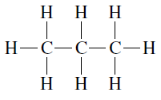 | 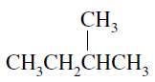 | 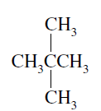
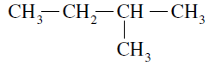 | 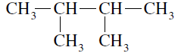 | 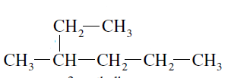
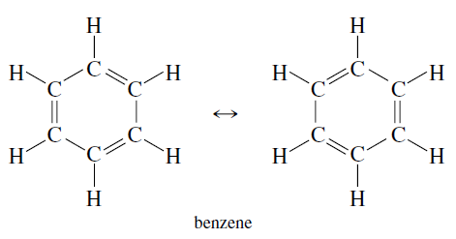
Aromatic Hydrocarbons
- these are sometimes referred to as “benzene ”
- their primary identification is the ring structure central to the atom
- the rings consists of alternating bonded - double bonded carbons
- it was later found that the six carbons form a massive hybrid 1.5 bond
- 1 bond from s-orbitals
- .5 bond from 3 bonds shared with six carbons

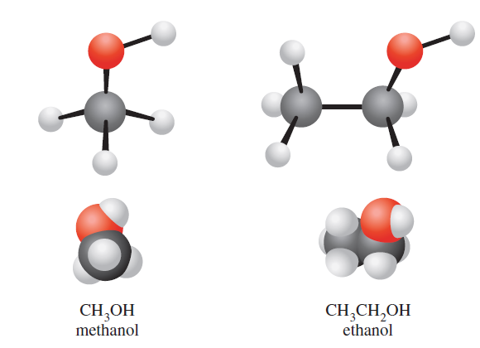
Functional groups
- these are distinct groups of atoms that attach to any hydrogen in a hydrocarbon
- they effectively replace a hydrogen
- they give very specific properties to any given molecule
- molecules of the same functional group are VERY similar in behavior

Alcohols
- characterized:
- this group is called the __________________
- the important part of this group is that it adds ____________________ to the molecule

The Carbonyl Group
- this group is characterized by:
* note the double bond
- if this is added to the end of a molecule, it’s called a _______________
Ex: Formaldehyde, CH₂O

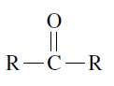
- if added somewhere “in the middle”, it’s called a _______________
Ex: Acetone, CH₃COCH₃

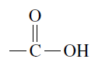
Carboxylic acids
- characterized by
- this group is called the
- WAIT! ACID?! HOW?!
* these release a H⁺ in solution =)
Ex: Acetic acid, CH₃COOH, reacts with sodium hydroxide. Show the chemical reaction;
label products.

Ethers
- characterized by the formula
* note that alcohols and ethers have the same formula
- it is important to know the name, so we know the structure!
Ex: C₂H₆O can represent either:

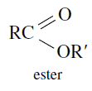
Esters
- characterized by
- created by the process of
- these smell GOOD!
- account for many artificial scents
Ex. Acetic acid and ethyl alcohol produce ethyl acetate and water.

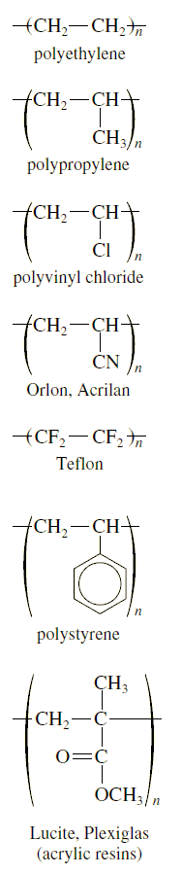
Polymers and Plastics
- polymers are LONG chain molecules
- they are made up of one or more monomers
- most polymers are made by addition polymerization
- must begin with an step called _____________
- this requires formation of a ______________________
- this causes the rapid step called ______________________
- finally, ___________________ results when radicals collide with each other and bond
* thus, polymers are of non-uniform length!

Ex Draw a polypropylene chain that is four monomers in length.

Biochemistry
Biology and chemistry are not mutually exclusive!
- biology must obey all chemical rules
- most of biology relies on _____________________
- these are giant molecules with molecular weights greater than even 100,000g/mol
- we’ll see only a few of these

Carbohydrates
- these are sugars and their polymers
- simple sugars serve as fuel for us (monosaccharides and disaccharides)
- examples are glucose, fructose, sucrose, lactose, and maltose
- polysaccharides have hundreds or thousands of monosaccharides
- animals store ______________; plants store __________________
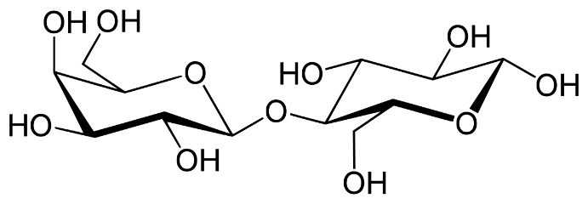
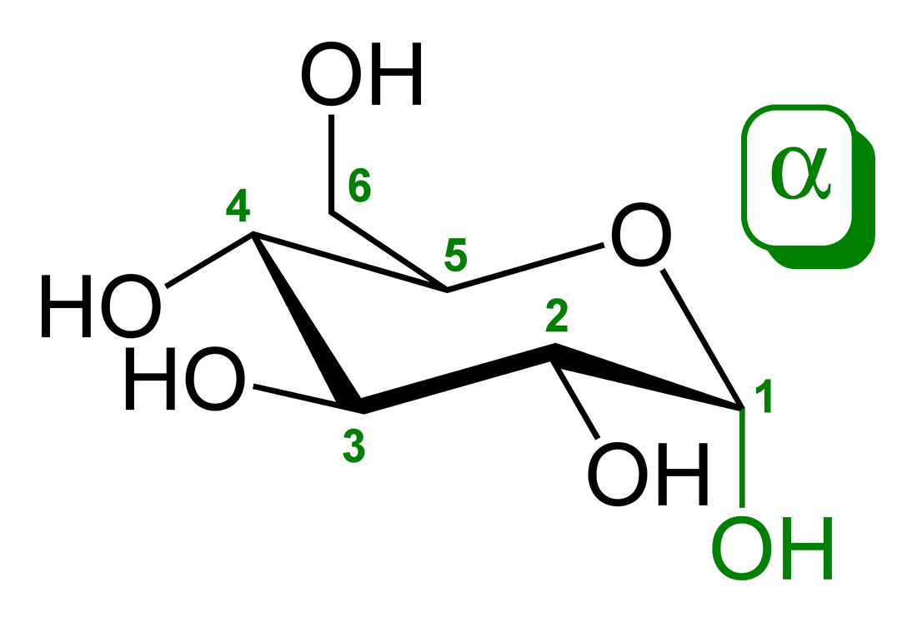
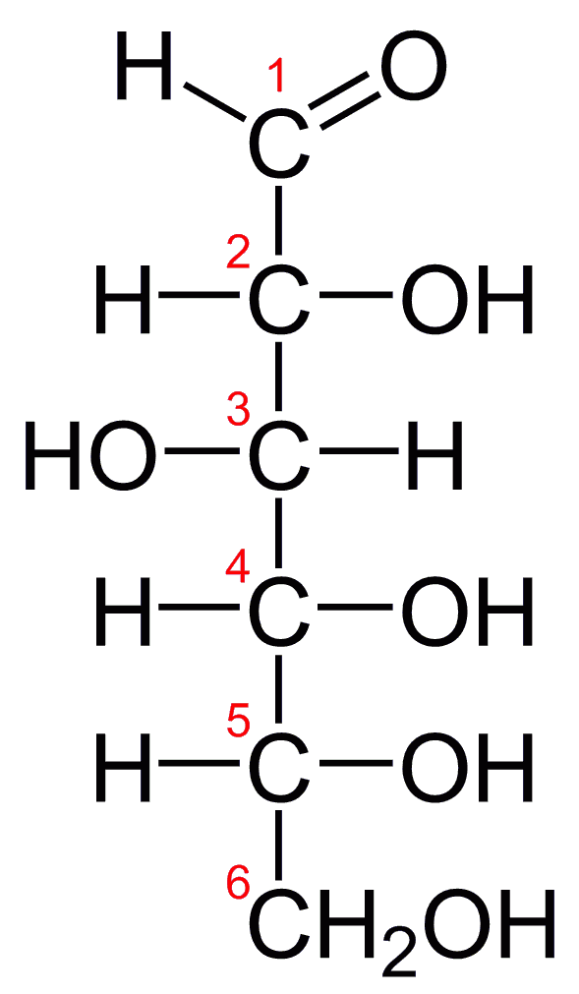
- animals may only sustain for about a day on this
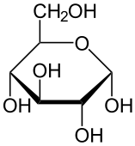

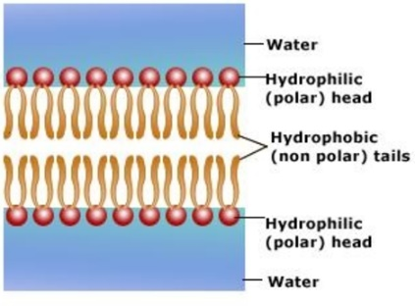
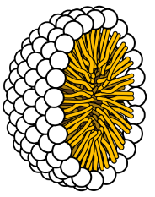
Lipids
- fat soluble molecules that are
- may be large molecules (about 16 – 18 carbons long)
- this class encompasses fats, oils, phospholipids, and steroids
- these can store a whole lot of energy!
- fats can be deposited as adipose tissue in mammals
- fats contain roughly twice as much energy as a polysaccharide
- also adds additional heat insulation
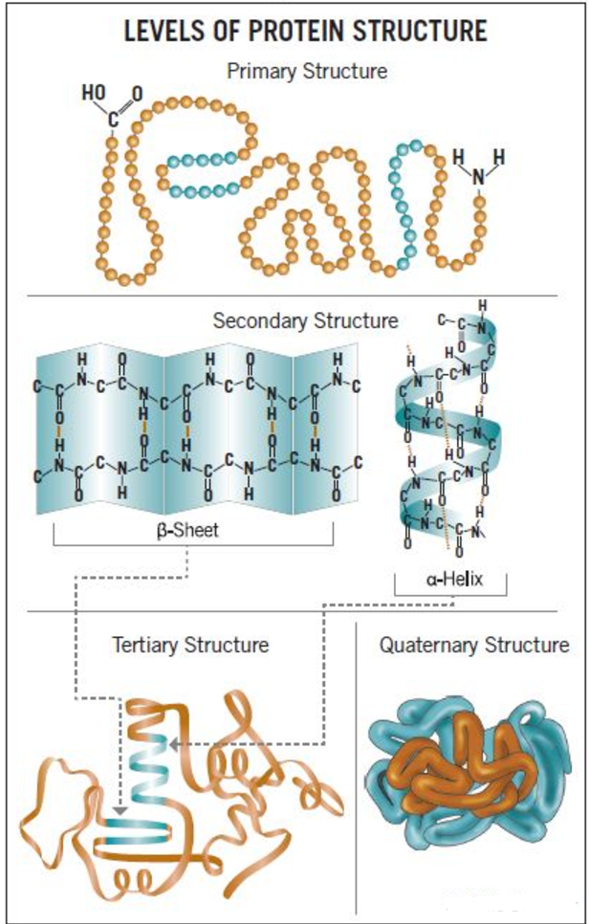
Proteins
- very very VERY important in biology!
- made of amino acid polymers, called a _______________________
- only 20 amino acids are required to make ALL proteins
- just different sequences
- function depends on 3-D ____________________
Primary structure: AA sequence
Secondary structure: foldings or helices caused by ______________
Tertiary structure: irregular contortions caused by side chains interactions
Quaternary structure: results from interactions between polypeptides
- if proteins heat up too much, they undergo _____________________
- structures break down, and thus protein does not exist anymore
- often cannot be put back how it should be

Enzymes
- biocatalysts for reactions that requires putting parts together or breaking them apart
- they are proteins themselves, and also are very important in putting proteins together (or breaking them down)

- a goes into an ezyme’s

- this forms a complex
- enzyme inhibitors are other molecules/proteins that may enter the active site, but cannot react
- thus, the actual substrate can’t enter and the reaction doesn’t happen
- this is not always a bad thing

- are inorganic compounds or elements that help enzymes to activate or function

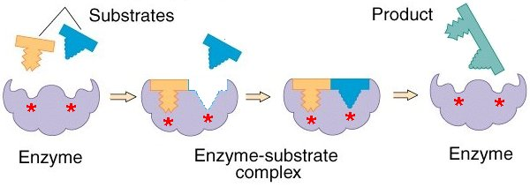

Nucleic Acids (DNA and RNA)
- their workings are beyond the scope of this class
- we may say it is made up of a nitrogenous base and a five-carbon sugar
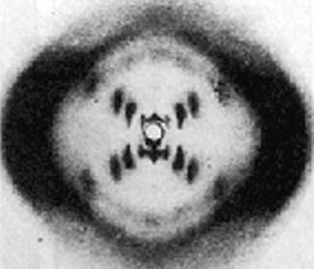
- each is held by a phosphate bridge
- all inheritance (and life itself) is due to this structure

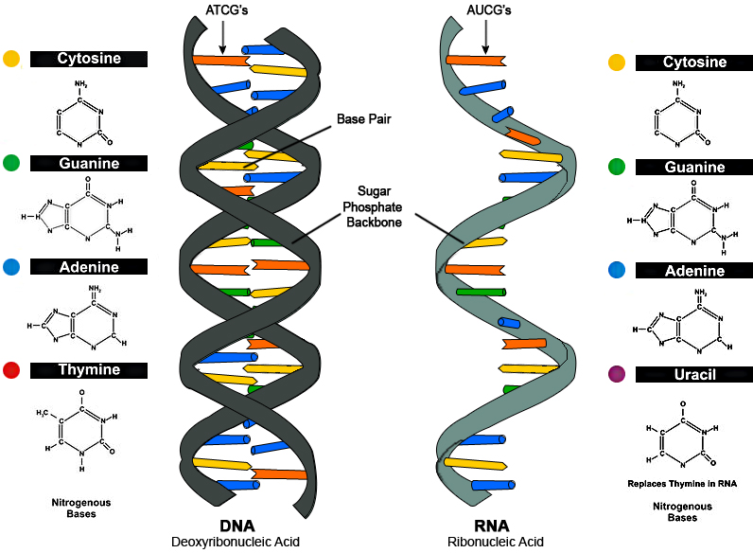
RNA:

- uses the sugar ribose
- single strand, using bases:
A = adenine G = guanine
C = cytosine U = uracil

DNA:
- uses the sugar deoxyribose
- includes the base T = thymine instead of U
- base pairs are always:

- two strands are held together by

- the resulting structure is a

- James and Francis originally proposed this structure

- Rosalind was the X-ray crystallographer who took the photo leading Watson and Crick to this conclusion

- the polymerase chain reaction ( )is used to multiply a single piece of DNA thousands of times over
- you place a single strand of DNA into a “soup” of nucleotides, a VERY specific DNA polymerase enzyme, and short pieces of synthetic strand DNA used as “primers” for synthesis

- recently, development of has allowed for the editing of genes of DNA
- this raises ethical questions of “designer” genes
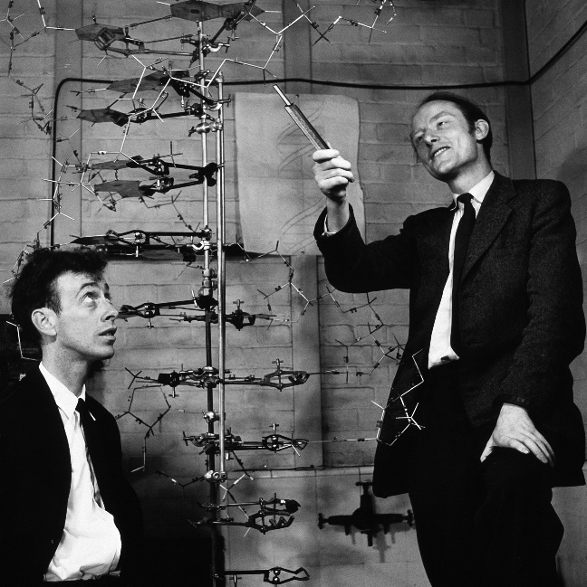
Amino Acids – Structures, Names, and Abbreviations
