Properties of Matter
Matter
- Matter is composed of
- Pure substances may be or

Elements
- Simplest pure substances
- Some elemental substances are made of multiple atoms
  - “diatomic” molecule
  - allotropes

Compounds
- Made of several elements in specific proportions
- Systematic naming tells you what types of atoms are in a compound, and in some cases the proportions
    - Examples:
Carbon dioxide Dinitrogen monoxide Carbon tetrachloride

  - Not always the case! Ionic compounds follow other rules.
Sodium chloride Magnesium chloride

Common Chemicals
- Common chemicals have both a name and a name
  - In many cases, the common name is accepted
    - Examples: Water Ammonia

Ex. Are the following elements, compounds, or both? Write the make-up of each.
a) S₈ b) H₂CO₃ c) CH₃COOH d) Mg(OH)₂ e) Ca₃(C₆H₅O₇)₂

Classification of Matter

Pure Substances
Elemental

Compound

States of Matter (three main)
 | Properties | Examples
Solid
Liquid
Gas
Other States of Matter
Amorphous

Plasma

Glasses

Classifying States of Matter
State | Shape | Volume | Compressible? | Flow?

Properties of Matter
- physical properties:
  - characteristics that are directly
- chemical properties:
  - characteristics that describe the behavior of matter
Mixtures
- Homogeneous:
  - every piece of a sample has identical characteristics, though another sample with the same components may have different characteristics
  - atoms or molecules mixed uniformly
- Heterogeneous:
  - contains regions within the sample with different characteristics
  - atoms or molecules not mixed uniformly
Ex Classify as a type of mixture.
Rubbing Alcohol | Soda | Italian Dressing | Sand | Blood

Separating mixtures
- separate mixtures based on different physical properties of the components (Physical change)
- Methods
  - Distillation
  - Filtration
  - Chromatography
  - Evaporation
  - Decanting

Periodic Table
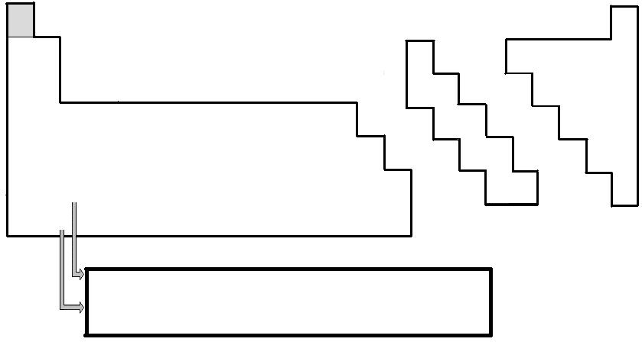
Types of Elements
Metals

Nonmetals

Metalloids

Changes in Matter
- Physical changes: changes that alter the or of the matter without altering
the composition
- Chemical changes: changes that alter the of matter are called
  - the atoms that are present rearrange into new molecules, but all of the original atoms are still present

Physical Changes

Chemical Changes

Temperature
- Conversion formulas:
- We use the Kelvin in Chemistry:
Ex Find the Fahrenheit and Kelvin temperatures on Venus, which has a constant temperature 462°C.

Heat:
- Three modes of heat transfer
  - Conduction
  - Convection
  - Radiation
- Specific heat:
- We can find the amount of energy transferred by the equation:
Ex How much energy is needed to raise 250mL of water from 12°C (out of the faucet) to 95°C?

States of Matter and Energy

Energy and Phase Diagrams

Latent Heat:

Ex How does ice melt in ice water?

