Separation of Lactose from Milk
Chemistry ^{Name}

OBJECTIVE: To measure the percent composition of lactose in a sample of milk.
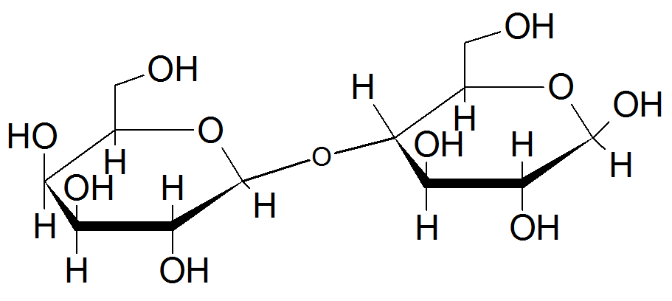
INTRODUCTION
Lactose is a sugar that occurs naturally in milk of mammals. As such, it is an important sugar for humans to study. Chemically, lactose is a disaccharide of galactose and glucose units, joined by a β-glycosidic linkage, as shown to the right.

Lactose can be recovered from the whey left behind after precipitation and removal of the milk proteins. In this lab, we use milk (or dry milk) as our lactose source. The first step is removal of the major protein in milk, casein. This is easily done by coagulation with acetic acid, then mechanically separating the solid proteins using cheese cloth. After this, lactose is the major water soluble component. Thus, water must be removed to leave the lactose powder behind.

MATERIALS
250mL beaker 100mL graduated cylinder Hot plate Buchner funnel
125mL beaker 25mL graduated cylinder Cheese cloth Filter paper
Erlenmeyer flask Thermometer Thiele-Denis tube

Chemical list
Milk sample 10% acetic acid CaCO₃ Oil (silicone or peanut)
decolorizing carbon 95% ethanol or 91% i-propanol Benedict’s Reagent (optional) Sugar samples

PROCEDURE
- Determine if you are using dry milk or liquid milk. Record the brand and type of milk.
  - Dry Milk Method
Measure 25g of nonfat dry milk powder on a balance using a weigh boat. Record the exact mass. Place this dry milk in a 250ml beaker. Add exactly 75.0mL warm water and stir to mix.
  - Liquid Milk Method
Measure 95mL of milk into a graduated cylinder. Record the exact volume. Place in a 250mL beaker.
- Place the beaker on a hot plate. Adjust the temperature of the mixture between 40-50°C while stirring. Once the mixture reaches this temperature, add 10ml of 10% acetic acid and stir to coagulate the casein.
- Remove the casein by gravimetric filtration through cheesecloth; this simply means you should pour the solution through the cloth, allowing it to catch the solid proteins. Collect the filtrate in a 250ml beaker.
You may gently wring cloth from the top, but keep in mind the strong vinegar solution.
- Add 2g CaCO₃ to the filtrate. Stir into the solution, and boil for 10min.
- Add decolorizing carbon (about nickel size) and stir into the solution.
- Vacuum filter using a Buchner funnel and a filter aid.
- Transfer the filtrate to a 250ml beaker and concentrate solution to about 30ml by boiling. Once reduced to 30ml, turn off the heat and add 125ml alcohol and decolorizing carbon (as in previous step).
- Stir mixture, and vacuum filter through a layer of filter aid.
- Allow the clear filtrate to crystallize at least 24 hours. Optional: place in an ice bath for immediate crystallization.
- End Lab Day 1 -
- After one day of crystallizing, collect lactose crystals by decanting or vacuum filtration. Dry product overnight.
- Optional: Wash crystals with 95% ethanol and filter again. Recrystallize. Dry overnight once again.
- End Lab Day 2 -
- Optional: Prepare a boiling water bath in a 400mL or 600mL beaker. Dissolve a small amount of dry product in 5mL of water. Place 5-10 drops of the sugar solution in a test tube. Dissolve several other test sugars (sucrose, etc) in test tubes similarly (or use sugar solutions). Place 2-5mL Benedict’s reagent in each test tube. Record results.
- Optional: Use a Thiele tube (shown on next page) to find the melting point of your dry sample.

DATA
Complete this data table while performing the lab. Use the data in your report and conclusions.
Fill in one of the following boxes:
Initial Milk Mass (solid) | Initial Milk Volume (mL)

Temperature (coagulating)
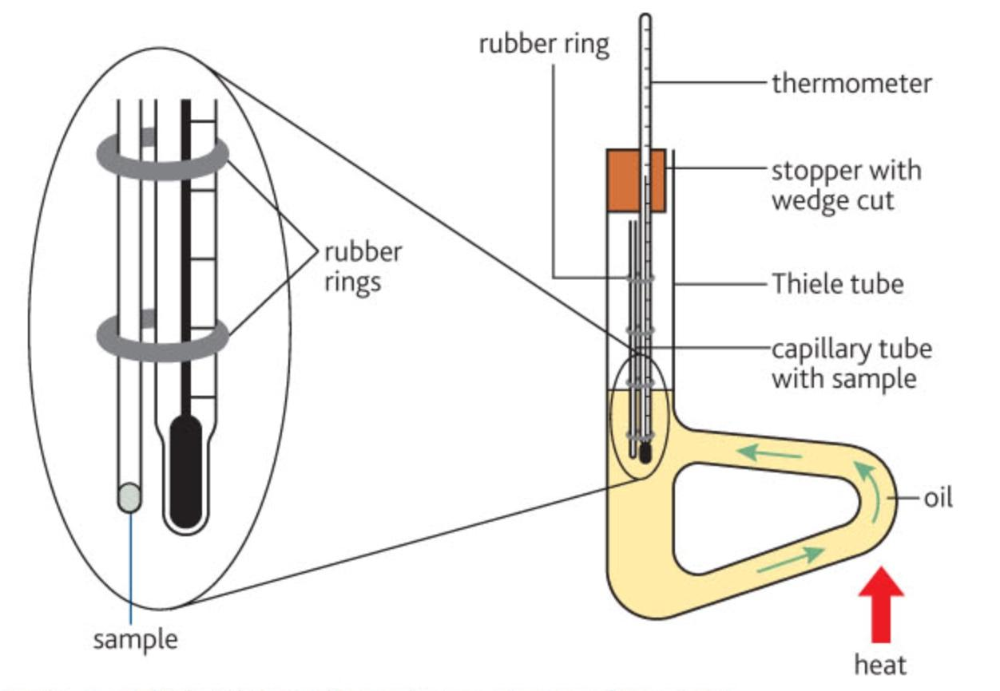
Melting Point Apparatus Setup

Mass Calcium carbonate

Decolorizing Carbon Used? YES NO

Final Dry Mass

Product Melting Point

Observations of Final product?

Benedict’s Reagent Tests
Sugar | Result color | Conclusion
Product
Sucrose

