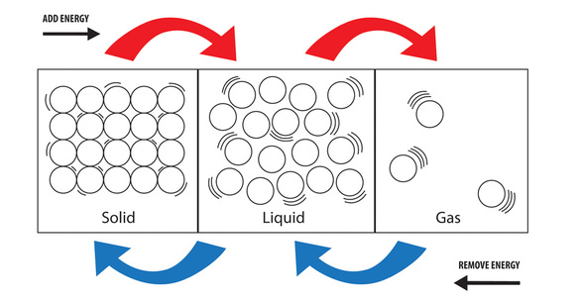Liquids & Solutions

States of Matter

- there are generally three states of matter, but here we focus on liquids

- these have some properties like solids and gases:

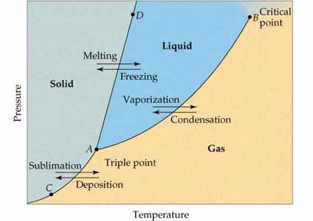

Changes of State

- the following six terms describe the three phase change boundaries

Ex Find the state of matter for CO2; mark on the phase diagram.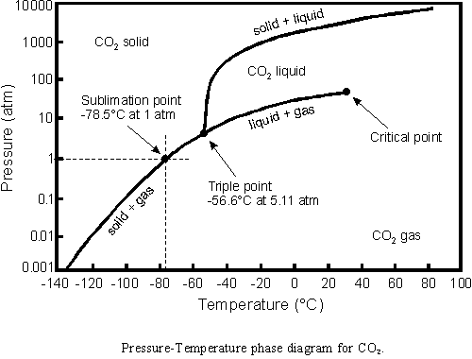

A) 0.5atm, 0.0°C

B) 100.atm,-20°C

C) -100°C, 0.1atm

D) 80°C, 50atm

These may occur by one phase or enough energy to change states

- the energy needed is known as the or

- the tabulated energy (per gram) is known as heat

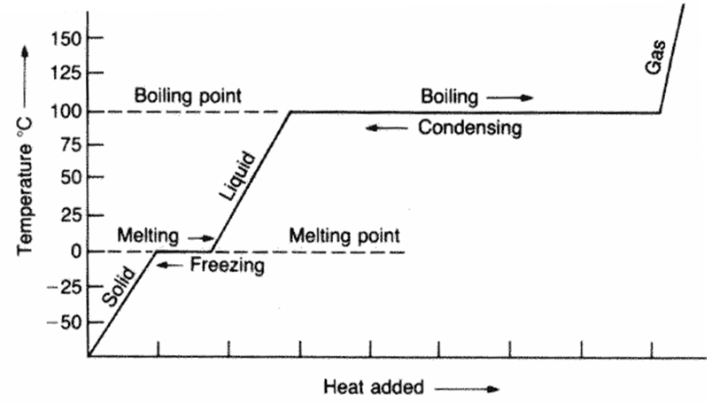

It is worth noting water’s known quantities (1.00atm):

*heat of fusion* 334 J/g

*heat of vaporization* 2260 J/g

*specific heat (liquid)* 4.184 J/g-°C

Ex Calculate the energy required to change

75mL of water at 24°C to ice.

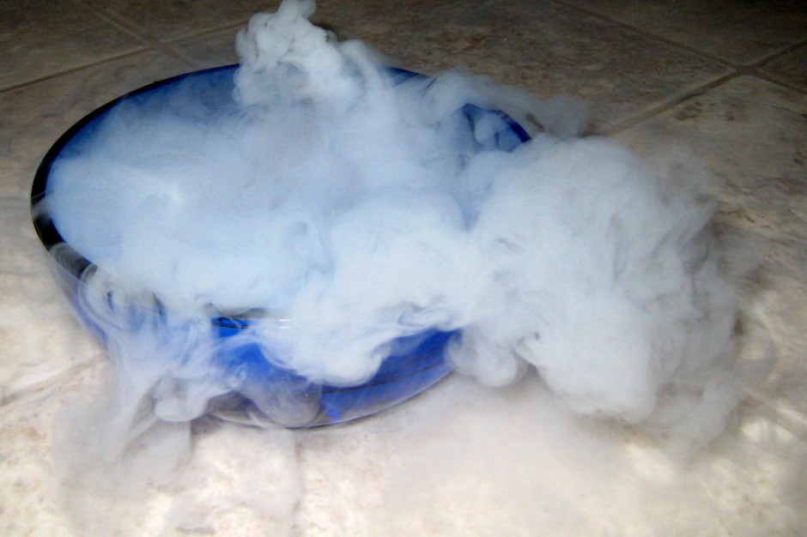Vaporization

- liquid particles at the may leave into the state

- only occurs if enough available

- since these particles escape with some , the surface is then

-vaporization can occur two ways from the liquid state:

- vaporization can also occur from the solid to gas states

- this is known as

Properties of Liquids at the Surface

The exerted by a gas on its state is the

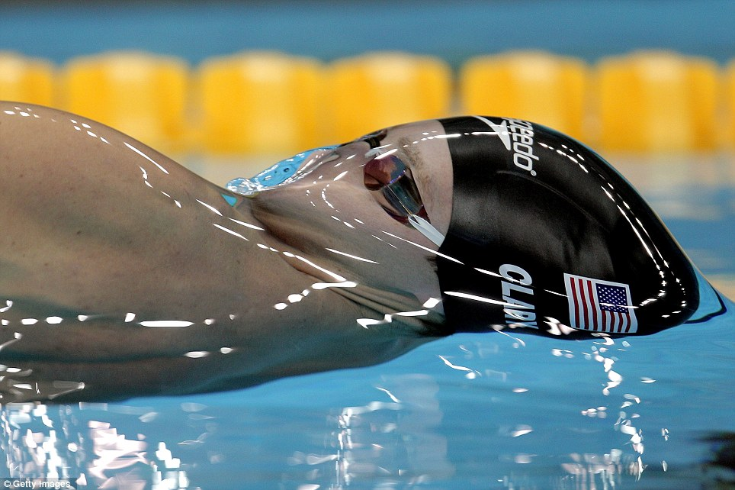

- this changes as a function of

- if low, the liquid is said to be

is resistance of a liquid

to a change in surface area

- this is due to forces between liquid particles

- if free, liquids will form droplets

In a column, a liquid may interact with the walls

- and forces balance to form one of two shapes of a

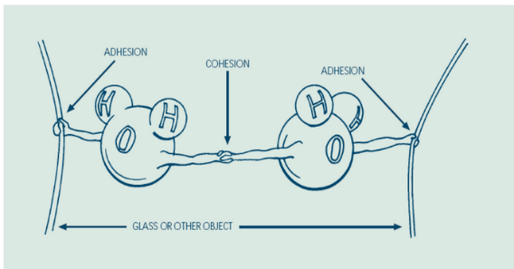- if dominates, a liquid may climb the walls of a narrow tube

- known as

Water

- many outstanding properties due to

- these are weak interactions due to

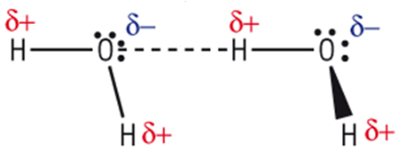

- usually occur between hydrogen and

- a notable property is that H-bonds help water freeze into a crystal

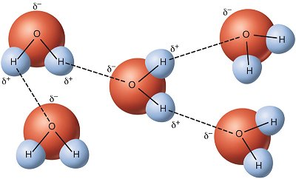 - this makes solid water than liquid water

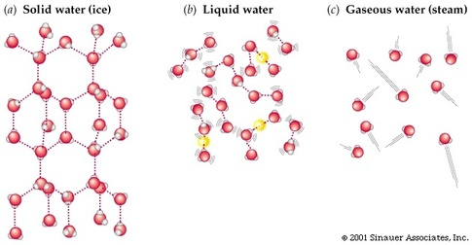

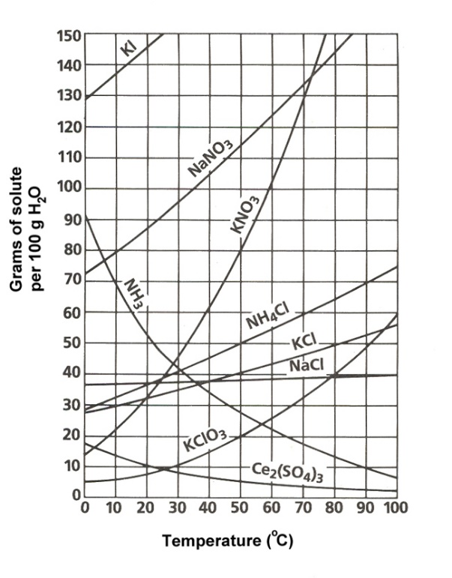Review of Mixtures

- two types:

- most chemistry of solutions involves defining theory and limits of

homogenous vs heterogeneous mixtures

SOLUTION:

- there are always two parts (at least):

1.

2.

- they can be separated by purely means

Ex Define the solute and solvent.

|  |  |  |  |
| --- | --- | --- | --- |
|  | Quik powder in milk | Club soda | Blood  *Quick Questions*  *Mark saturated (S), unsaturated (U)or precipitate (P) for each mass dissolved in 100g of water.*  a. 20gNH3 @ 50°C  b. 60gNH4Cl @ 70°C  c. 10g NH3 at @ 90°C  d. 120g KNO3 @ 60°C  e. 30g KCl @ 15°C  f. 100g KI @ 0°C |
| Solute |  |  |  |
| Solvent |  |  |  |

SOLUBILITY:

- dependent on conditions like and

- we say *soluble*, *insoluble*, or *slightly soluble* to describe this phenomena

- ability to mix is described on a

- we can then describe a solution one of three ways

1.

2.

3.

Ex Calculate the number of moles of potassium nitrate dissolved in a **saturated** solution with 500.g of water at 70°C.

Miscibility

- two liquids that can mix all are said to be (otherwise )

- mainly dependent on :   
 POLARITY:

Ex Are the following polar? Indicate the polarity.

|  |  |  |  |  |  |  |  |
| --- | --- | --- | --- | --- | --- | --- | --- |
| H2O | CO2 | CH2O | NH3 | C2H5OH | C3H8 | CH3Cl | CH4 |

**Factors of Dissolving Solids in Liquids**

1 Size/Area 2 Temperature

3 Concentration 4 Agitation

CONCENTRATION:

- there are many measures, in terms of numbers (moles), grams, or volume of parts

- we can define many concentrations, including by mass or volume:

- in chemistry, the most common form is **MOLARITY**

*\*Note: when mixing solids into liquids, we generally don’t consider solid volume since, once dissolved, it changes volume to become part of the liquid*

Ex We dissolve 91g of AgNO3 in 500mL of water. What is the molarity?

Ex We need to make 5.00L a 3.00M solution of KOH. How much KOH solid should we use?

When working with liquid solutions, changing molarity involves a simple formula

- consider that changing the molarity always requires changing solution volume, but the number of moles of solute don’t change

- for a dilution, we just add more volume of solvent

- to increase concentration, you may boil away some solvent (to lower volume)

- this is hardly ever done

- the **simple** formula is:

Ex We would like to dilute full strength 17.5M acetic acid down to 0.01M, the strength of common vinegar. How much vinegar can be made with 250.mL of full-strength acetic acid?

Ex 250.mL of water is accidentally added to 1.00L of 6.0M HCl. What is the molarity after this slight lab mishap?