Synthesis of Aspirin
INTRODUCTION
Aspirin, first synthesized in 1897, is one of the oldest, yet most common, drugs in use today. Like many modern drugs, aspirin has its roots in an ancient folk remedy—the use of willow extracts to treat fever and pain. Aspirin is prepared the same way today that it was more than 100 years ago. Let’s look at the structure, synthesis, and properties of aspirin.

BACKGROUND
Native Americans, as well as the ancient Chinese, Egyptians, and Greeks, used willow extracts to treat fever, pain, and inflammation. The Ebers papyrus, dating to at least 1500 b.c. in Egypt, contains the earliest written reference to the use of willow extracts, “to draw the heat out” from inflammation. Willow extracts remained a popular folk medicine remedy throughout the middle ages. The first scientific study of the effectiveness of willow extracts was carried out in 1763 by the Rev. Edward Stone in England. In one of the first ever “clinical trials” of a drug, Stone reported using willow extracts to treat fever and pain in more than 50 patients suffering from malaria.

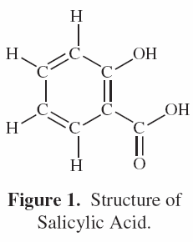
In the early 19th century, organic chemistry was only a fledgling science, with roots in the study of natural products. In 1828, Johann Büchner at the University of Munich in Germany isolated a crystalline compound from willow bark and named it salicin, after the Latin name for the white willow, Salix alba. Ten years later, the Italian chemist Raffaele Piria converted salicin to salicylic acid, which had also recently been isolated from meadowsweet flowers (Spiraea). Salicylic acid (Figure 1) was found to be the active ingredient responsible for the medicinal properties of many plants, including willow, poplar, aspen, and myrtle. In 1859, Hermann Kolbe at Marburg University in Germany determined the chemical structure of salicylic acid and synthesized it from phenol, a derivative of coal tar. By 1870, salicylic acid was widely used in Europe for the treatment of arthritis, pain, and fever. Unfortunately, the compound was “tough to swallow” and very irritating to the stomach. Many people could not tolerate the drug because of its severe and unpleasant side effects.

Felix Hoffmann, an organic chemist working at Friedrich Bayer and Company in Germany, attempted to chemically modify salicylic acid and thus reduce its side effects. In 1897, Hoffmann prepared acetylsalicylic acid by reacting salicylic acid with acetic anhydride (Equation 1).
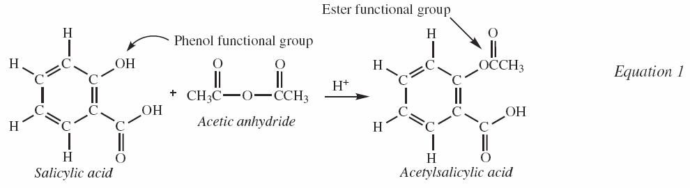
The synthesis of acetylsalicylic acid is an example of an esterification reaction in which the phenolic –OH group in salicylic acid is replaced with an acetyl or ester functional group (–OCOCH3). Masking the –OH functional group in this way makes the compound less acidic. Acetylsalicylic acid is an effective analgesic (pain reliever) and antipyretic (fever reducer) but is less acidic or harsh than salicylic acid. In 1899, the Bayer Company marketed acetylsalicylic acid under the trade name aspirin, with a- denoting the acetyl group and –spirin referring to Spiraea, the plant from which salicylic acid was first isolated. It is estimated that approximately 50 billion aspirin tablets are consumed per year all over the world, and that as many as one trillion (1 × 10¹²) aspirin tablets have been produced in the 100 years since its discovery!

Acetylsalicylic remains a versatile drug in the 21st century. The two most common uses of aspirin today are for the prevention of heart attack and stroke and to relieve the pain and reduce the inflammation of arthritis. The American Heart Association recommends “an aspirin a day” to prevent a second heart attack in individuals who have had a previous heart attack or stroke. The myriad physiological effects of aspirin were explained in 1972 by Sir John Vane (Nobel Prize in Medicine, 1982) and coworkers at the Wellcome Research Laboratories in Great Britain. Vane found that aspirin inhibited an enzyme involved in the synthesis of prostaglandins and thus interfered with their production in the body. Prostaglandins are hormone-like “chemical messengers” that play a key role in a variety of physiological processes, including inflammation, blood clotting, labor and childbirth, and blood pressure. Aspirin prevents the formation of blood clots that are a major cause of heart attacks and strokes.

EXPERIMENTAL OVERVIEW
The purpose of this experiment is to prepare acetylsalicylic acid (aspirin), determine its purity, and investigate its chemical properties.

PRE-LAB QUESTIONS (Read the entire Procedure and the Safety Precautions.)
- Acetic anhydride is a lachrymator. What is a lachrymator and what safety precautions should be followed when working with acetic anhydride?
- What is concentrated sulfuric acid used for in this experiment? What are the hazards of working with concentrated sulfuric acid?
- Calculate (a) the molar mass of salicylic acid and acetic anhydride and (b) the number of moles of each that will be used in this experiment. Note: The density of acetic anhydride is 1.08 g/mL.
- Define the term limiting reactant. Complete the following statement: The maximum number of moles of aspirin that can be obtained in this experiment is equal to the number of moles of _____________________ used.
- Determine the chemical formula of acetylsalicylic acid and calculate its molar mass.

MATERIALS
Acetic anhydride, (CH₃CO)₂O, 1 mL Capillary tubes
Aspirin tablet, crushed Erlenmeyer flasks, 50- and 100-mL
Ethyl alcohol, CH₃CH₂OH, 50%, 6 mL Filter paper (to fit funnel)
Ethyl alcohol, 95%, 3 mL (optional) Funnel
Iron(III) chloride solution, FeCl₃, 0.1 M, 1 mL Graduated cylinder, 10-mL
Salicylic acid, HO-C₆H₄-CO₂H, 0.6 g Hot plate
Sulfuric acid, concentrated, H₂SO₄, 18 M, 2 drops Melting point apparatus or Thiele-Dennis tube
Distilled water and wash bottle Pasteur pipet
Ice, crushed Ring (support) stand and clamp
Balance, 0.01-g precision Stirring rod
Beaker, 50-mL Test tubes, small, 3
Beakers, 250-mL, 2 Test tube rack
Beral-type pipets, graduated, 4 Thermometer
Boiling stone Watch glass

SAFETY PRECAUTIONS
Concentrated sulfuric acid is severely corrosive to eyes, skin, and body tissue. Notify the teacher immediately in the event of a spill. Acetic anhydride is a corrosive liquid and the vapors are highly irritating. The liquid is flammable and a strong lachrymator—contact with the liquid will cause severe eye irritation. Work with acetic anhydride in the hood or in a well-ventilated lab only. Do not inhale the vapors. Salicylic acid is moderately toxic by ingestion. Avoid contact of all chemicals with eyes and skin. Wear chemical-splash goggles, chemical-resistant gloves, and a chemical-resistant apron. Wash hands thoroughly with soap and water before leaving the laboratory.
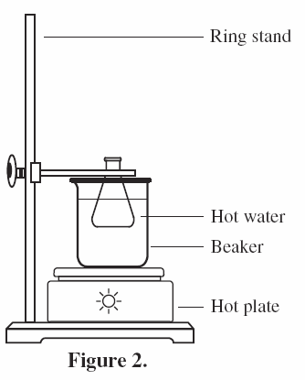
PROCEDURE
- Fill a 250-mL beaker about two-thirds full with hot tap water and add a boiling stone.
- Place a hot plate on the base of a ring (support) stand and place the beaker on the hot plate. Heat the water to about 80 °C using a medium-high setting of the hot plate.
- Tare (zero) a clean 50-mL Erlenmeyer flask. Place about 0.5 g of salicylic acid in the flask and measure the precise mass to 0.01 g. Record the mass of salicylic acid in the data table.
- Take the Erlenmeyer flask to the hood where the acetic anhydride is being dispensed. Carefully add 1 mL of acetic anhydride to the flask using a graduated Beral-type pipet.
- Using a glass eyedropper or Pasteur pipet, carefully add 2 drops of concentrated sulfuric acid to the Erlenmeyer flask.
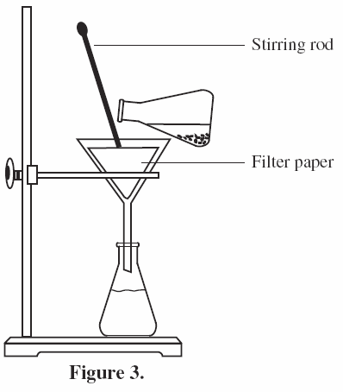
- Place the Erlenmeyer flask in a clamp and attach the clamp to the ring stand. Carefully lower the Erlenmeyer flask into the 80 °C water bath. See Figure 2.
- Heat the reaction mixture in the hot water bath for 10 minutes.
- Half-fill a second 250-mL beaker with crushed ice and water to use as an ice bath. Obtain about 15 mL of distilled water in a small beaker or test tube and place the beaker in the ice bath to chill the water.
- After 10 minutes, raise the clamp and carefully lift the Erlenmeyer flask out of the 80 °C water bath.
- Allow the Erlenmeyer flask to cool, then add 3 mL of ice-cold water (from step 8) dropwise to the reaction mixture. Note: Water will react vigorously with acetic anhydride to form acetic acid. A vinegar smell may be noticed.
- Add an additional 5–6 mL of ice-cold water to the Erlenmeyer flask and place the flask in the ice bath (step 8) to allow the aspirin to crystallize. If no crystals have formed after 5 minutes, remove the flask from the ice and scratch the sides of the flask with a stirring rod.
- Keep the flask in the ice-water bath for 10 minutes to complete crystal formation.
- Set up a funnel for gravity filtration as shown in Figure 3. Place a clean beaker or flask under the funnel to collect the filtrate. Wet the filter paper with a few drops of distilled water.
- Using a stirring rod to direct the stream of liquid, slowly pour the reaction mixture from the Erlenmeyer flask into the funnel. Gently swirl the flask to get as much of the solid as possible into the funnel with just one pour.
- When most of the liquid has passed through the funnel, rinse any remaining crystals from the flask into the funnel with a small amount (no more than 4 mL) of ice-cold water.
- Measure and record the mass of a clean and dry watch glass to the nearest 0.01 g. When there is no more liquid in the funnel, carefully remove the filter paper and scrape the crystals onto the preweighed watch glass. Note: If the product will be recrystallized (step 17), transfer the crystals to a clean 50-mL Erlenmeyer flask
- (Optional) To recrystallize the product, dissolve in 3 mL of 95% ethyl alcohol and gently heat (do not boil) the mixture on a hot plate. Add about 6 mL of distilled water to the hot solution until the solution is slightly cloudy. Cool the flask in an ice bath to obtain crystals and then repeat steps 13–16 to filter and wash the crystals.
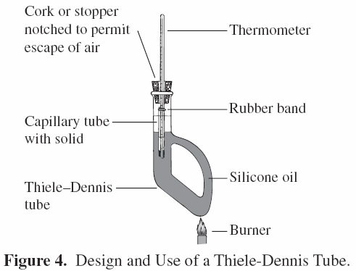
- Label the watch glass with your initials and allow the crystals to air dry for at least 2 hours. Measure and record the combined mass of the watch glass and aspirin in the data table.
- Label three small test tubes A–C and add a small amount (about 20 mg) of (a) salicylic acid, (b) the reaction product, and (c) crushed aspirin to the appropriate test tube.
- Add about 2 mL of 50% ethyl alcohol to each test tube to dissolve the solids.
- Add 3 drops of 0.1 M iron(III) chloride solution to each test tube. Record observations in the data table.
- Use a Thiele-Dennis Tube with silicon oil (alternatively, vegetable or peanut oil are also acceptable) to find the melting point of your product.

DISPOSAL
Dispose of the reaction product as directed by the instructor.

DATA TABLE
Mass of salicylic acid used
Mass of watch glass
Mass of watch glass and acetylsalicylic acid
Melting point of acetylsalicylic acid
Results of Fe³⁺ Tests — Observations
Salicylic acid
Reaction product
Crushed aspirin

POST-LAB QUESTIONS
- Calculate the number of moles of salicylic acid used in this experiment.
- Calculate the maximum amount of acetylsalicylic acid in grams that may be obtained from this amount of salicylic acid. This is the theoretical yield. Hint: See Pre-Lab Questions #4 and 5.
- Determine the mass of aspirin obtained in this experiment and calculate the percent yield.
- 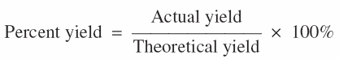
- Iron(III) ions are used as a qualitative test for phenols (aromatic compounds containing an –OH functional group). (a) What compound was used as a positive control for the Fe3+ test in this experiment? (b) Did the reaction product give a positive or negative test with Fe³⁺ ions? Explain.
- Old aspirin tablets often have a faint vinegar (acetic acid) smell and give a positive test with iron(III) ions. Write a balanced chemical equation for the hydrolysis of aspirin (reaction of aspirin with water) to explain these observations.
- Acetic anhydride was used in excess in this experiment. What does this mean, and how was the excess acetic anhydride decomposed at the end of the reaction?
- Look up the melting points of salicylic acid and aspirin (acetylsalicylic acid) in a reference book or online and compare with the melting point of the reaction product.

